Conteúdo
About 2
What are Factual Questions? 3
What is Scanning? 4
What are Negative Factual Questions? 5

About
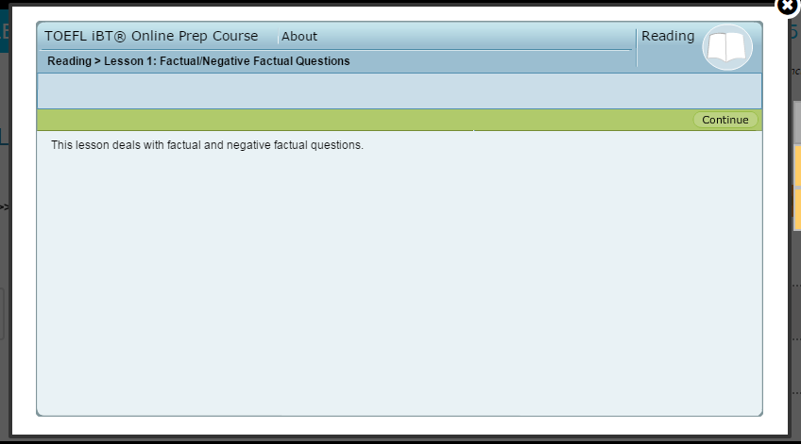

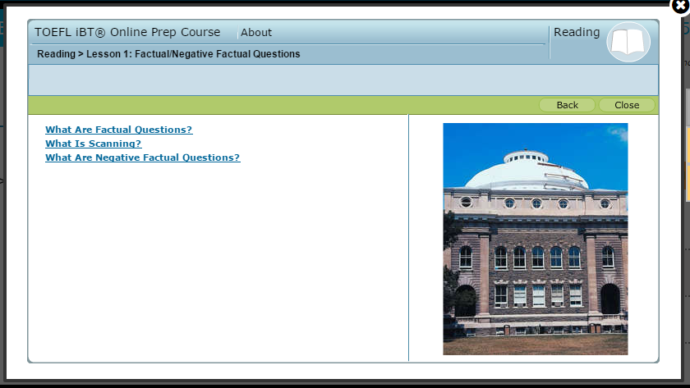

What are Factual Questions?

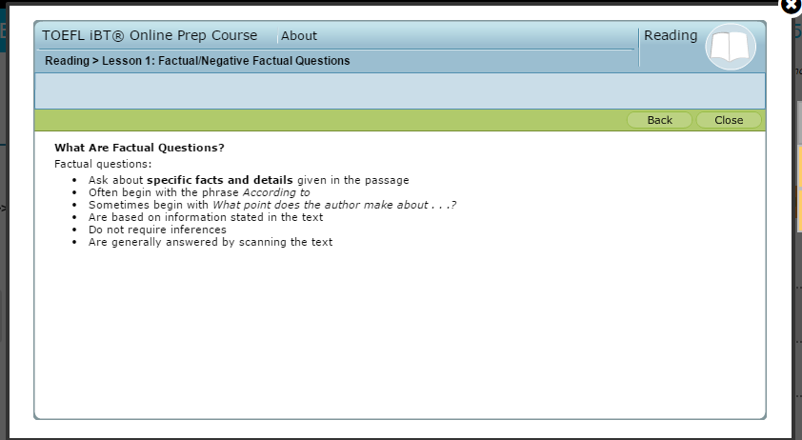

What is Scanning?

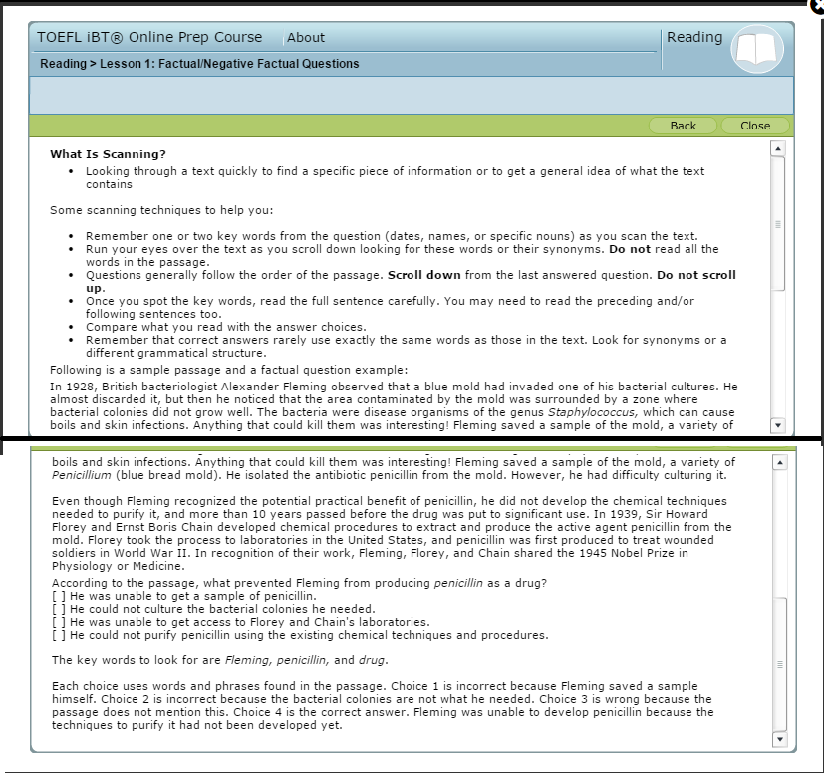

What are Negative Factual Questions?

